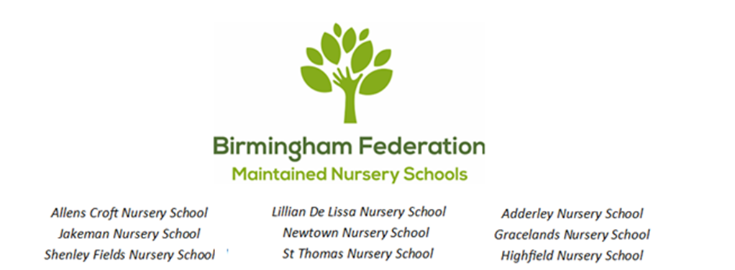

Healthy Food and Drinks Policy
Allens Croft & Shenley Fields Nursery Schools

Statement of Intent
We recognise the importance of introducing healthy foods and good eating behaviours at an early age to promote healthy weight and good oral health.
This policy aims to:
- ensure that all aspects of food and nutrition in our setting promote the health and wellbeing of children, families, carers, and staff; provide a hygienic, healthy environment wherever food is offered; and promote healthy eating habits that will lead to lifelong health and wellbeing
- reduce intake of sugar in children’s diet to prevent tooth decay and excessive weight gain
- prevent poor speech and language development which can be caused by inappropriate use of drinking vessels and tooth decay
- encourage a happier and calmer population of children
As a nursery we are required to support you with information to help you to provide healthy meals for your child whilst onsite. To meet our Ofsted welfare requirements and The Department for Education Nutrition Guidance, we are advised to limit the amount of ultra-processed, high fat, high salt or high sugar foods as these have a detrimental impact on their health and wellbeing.
General Procedures

- Food Provision: Children are provided with a two-course meal at lunch time. The main course is a hot meal. This is provided by City Serve. Menus are age-appropriate and in line with the Department for Education Early Foundation Stage Nutrition Guidance.
Individual dietary and cultural requirements will be respected and catered for as necessary, this considers SEND children and inclusive practice.

- ‘Milk and Water Only’ Setting:
We recognise that tooth decay is largely preventable, yet highly prevalent. Because of this, we are committed to being a “milk and water only” setting. Drinks from home are not permitted in nursery with the exception of:
- breast and formula milk
- reasonable adjustments made for children with SEND/ medical needs.

All staff will act as good role models for children and will only have water bottles that contain water in all the nursery provisions.

Water
- Birmingham tap water is fluoridated to protect enamel on teeth. We therefore provide fresh tap water
- Water will be freely available throughout the day
- Each room has a water station with water jugs and cups
- Water jugs and cups are provided on dining tables at meal times

Milk
Milk provides a source of calcium to keep our bones and teeth strong and healthy. For children under 1 year of age breast milk or suitable infant formula milk should be the only milks given as a drink. From 6 months of age full fat cows’ milk (or alternative) can be used in food preparation.
From 1 year of age, children can be given either full fat or semi-skimmed cows’ milk, providing there are no issues with faltering growth. The calcium in full fat and semi-skimmed milk is the same, but semi-skimmed milk has less fat.

Drinks from Home
Drinks from home are not permitted in nursery with the exception of:
- breast and formula milk
- reasonable adjustments made for children with SEND/ medical needs

Drinking Vessels
- Free flow beakers and unlidded cups are provided by our nursery
- Bottles are not permitted in nursery for infants over 12 months (we understand that reasonable adjustments may need to be in place for children with SEND/ medical needs)
- Milk cartons with straws
- None-spill beakers are not permitted in nursery

Monitoring
All staff are responsible for monitoring this policy. Unsuitable drinks and drinking vessels will be returned to parents.

- Appropriate Portion Sizes: Snack and meal quantities are provided in line with the Startwell guidance and the character ‘Micky me size’.

- Introducing a Variety of Tastes and Textures: Mealtimes and snack times will be used to introduce a variety of fruits and vegetables.

- Fun and Positive Mealtimes: We recognise the importance of creating a relaxed and fun atmosphere at mealtimes as this can help children to make positive associations with healthy eating. Staff sit with children (Suzy Startwell the positive role model) where possible to show a good example of table manners, introduce new foods and model good eating practice. Areas used for meal and snack times are clean and bright and the tables set with tablecloths and child sized cutlery. We use positive language and stay away from language such as “because it’s healthy”. We focus on the positive health outcomes from fruit and vegetables, for example “it makes you feel full of energy”. Children who are slow eaters will be given time and not rushed. We recognise that all children have different appetites and will not pressure them to finish their meal if they explain that they are full. To reduce food waste, we serve small portion sizes to start with, and support children to ask for more if they wish.

- Healthy Eating Behaviour: We do not use food as a reward or treat for good behaviour. Children will be encouraged to say “please” and “thank you”. Conversation will be encouraged at mealtimes, but not shouting. Children are provided with opportunities to feed themselves (and learn cutlery etiquette). Children will be supported to make choices about what they would like to eat at snack time by preparing and serving some of their food themselves as appropriate.

- Food Education: Helping children to understand where food comes from can encourage children to increase the variety of food they eat. Food and nutrition are included in the curriculum through growing vegetables and herbs within the setting, cooking with setting’s grown vegetables, reading books which include healthy foods, kitchen role play with real vegetables, sensory play using food. Children learn about healthy life styles through the Startwell characters and their messages.
- Fussy Eating: Fussy eating is common in children aged between the ages of 2-5 years. We recognise the importance of children hearing the same messages around healthy food habits, from all early year’s care providers and at home, as this can help support their eating habits. Children not on special diets will be encouraged to try a small piece of everything. If a child refuses to eat certain foods, they will not be pressured. Where a child’s eating behaviour has continued for an extended period and parent/carer/EY professional raises concerns that it is affecting a child’s wellbeing, it is recommended that the families contact their Health Visitor and/or GP to discuss their concerns.

- Staff Training: To ensure that we are providing children and families with a consistent and reliable information around food and nutrition, key staff at Allens Croft and Shenley Fields Nursery Schools have attended: food hygiene, allergy awareness, oral health, weaning, fussy eating, food and meal times and Startwell characters and messages training.

- Allergies: In accordance with the EYFS Statutory Framework, before a child is admitted to our setting, information will be obtained about any special dietary requirements, preferences, and food allergies that the child has. All staff will have knowledge of children’s allergy list and where to find it. Lunch boxes provided by home will not contain any form of nuts or eggs and grapes/ cherry tomatoes must be cut appropriately (into quarters) by parent/ carers when preparing lunch box.

- Infant Feeding: We recognise the importance of providing a consistent message amongst staff who work within early years settings when providing support and education for families around infant feeding and development. For more information, please speak to Sallyanne Bromley our Startwell lead practitioner.

- Introducing Solid Foods: We recognise the importance of introducing a baby to solid foods alongside breast milk or first infant formula at around 6 months old and when they clearly show all three developmental signs of readiness. For more information visit https://startwellbirmingham.co.uk/weaning/ .

- Food Safety and Hygiene: All staff handling food have completed a Food Hygiene and Safety certificate. The setting has a designated area that is adequately equipped to provide healthy snacks and drinks for children as necessary, including sterilisation equipment for babies’ food. Children and staff are required to wash their hands before eating meals and snacks. If two or more children suffer the effects of food poisoning after eating on the premises, Ofsted will be notified as soon as reasonably practicable or within 14 days. Please refer to Food Safety and Hygiene Policy for more information.

- Cultural Differences: If a child follows dietary habits linked to their religion/ cultural this should be recorded upon the child’s registration, giving the parent/ carer opportunity to provide more details if needed. Differences in eating habits will be respected. Menus will include meals that accommodate religious/ cultural dietary habits, vegetarian options are always available.

- Celebrations/ Events: When food is provided at a celebration/event, all food provided must be in line with the Department for Education Guidance. Celebrations/events should not be used to provide or promote foods high in fat, salt, and sugar for example, we discourage food items to be brought into the setting, such as birthday cake or sweets. Instead, we use cultural celebrations to introduce new foods at mealtimes, such as pumpkin soup at halloween or baked samosas at Diwali. Celebrations/ events are marked in other activities such as decorating rooms, games, crafts, songs, and stories. Celebrations/ events are marked using other activities such as by singing ‘happy birthday’ and via the playing of a party game.

- Nursery Healthy Packed Lunch Policy
To ensure that all packed lunches brought from home and consumed in nursery (or on trips) provide the child with healthy and nutritious food for growth and development. Objectives
• To make a positive contribution to children’s learning and development
• To encourage a happier and calmer population of children and young people

Support & Guidance
This policy was formed with support from an NHS Startwell nutritionist. Startwell menu guidelines are based on The Department for Education and Early Years Foundation Stage nutrition guidance.

Our Nursery Facilities
• The nursery will provide facilities for children bringing in packed lunches and ensure that fresh, plain, tap water is available on the dining tables throughout lunch time.
• The nursery will work with parents to ensure that packed lunches abide by the standards listed below.
• As fridge space is limited children are advised to bring packed lunches in insulated bags with freezer blocks where possible to stop food getting warm.

What to Bring
Packed lunches should always include the following on a daily basis:
• A minimum of 1 portion of fruit or vegetables for vitamins and minerals
• A starchy food for energy and concentration e.g., any bread, wrap, chapatti, pasta, rice, noodles, potatoes.
Do not bring flavoured dried rice, pasta, and noodle products e.g., packets and pots of instant noodles, pasta, and rice.
• Meat, fish or a plant-based source of iron and protein e.g., lentils, kidney beans, for cognitive development.
• Dairy or dairy alternative food e.g., cheese, plain unsweetened yoghurt or fromage frais, for growth of bones and teeth.

Drinks:
• Plain tap water will be provided by the nursery throughout the day and during lunch time, so you do not need to send any other drinks. Milk is provided for the children at afternoon snack time. Reasonable adjustments are made for children with SEND/ medical needs

Processed Foods:
• Processed meats e.g., ham and salami are high in fat and salt, limit to once a week and choose a healthier sandwich filling such as cheese, tuna, or chicken instead.
• Food’s high in fat and salt e.g., crisps, sausage rolls, pasties, fried samosa are not a healthy option for your child’s packed lunch.
• Food’s high in sugar e.g., chocolate bars, chocolate coated biscuits and sweets are not a healthy option for your child’s packed lunch.

Healthy Dessert Options:
Fresh fruit, tinned fruit in juice.
Fruit and plain unsweetened yogurt or fromage frais.

Guidance on Portion Sizes
Children should be eating ‘Micky me size meals. Toddlers and children have smaller stomachs than adults so it is important they eat smaller amounts of food. Putting too much food in lunchboxes can be overwhelming and stop children enjoying mealtimes. It can also lead to overeating and fussy eating.

Special Diets and Allergies
Due to the high risk of nut allergies, we do not allow children to bring foods containing nuts. The nursery also recognises that some children may require special diets that do not allow for the guidelines above to be met exactly. These should be discussed with nursery and parents are urged to be responsible in ensuring that packed lunches are as healthy and close to the guidelines as possible. For these reasons children are also not permitted to swap food items.

Monitoring & Review:
Packed lunches will be regularly reviewed by staff. Once a year the nursery will carry out a packed lunch audit and healthy packed lunch promotion to encourage children and parents to enjoy healthy packed lunches. This also supports us with our Ofsted inspections and work towards/ maintaining the Startwell Advanced Award.
The nursery will inform all parents and carers of the policy via Tapestry, display boards, parent workshops, parent consultations, induction paperwork and one to one conversation.

Signed: ____________________________ Sally Andrews
Chair of Local Committee

Signed: ____________________________ Sean Delaney
Chair of Governors

Signed: ____________________________ David Aldworth
Executive Head Teacher

